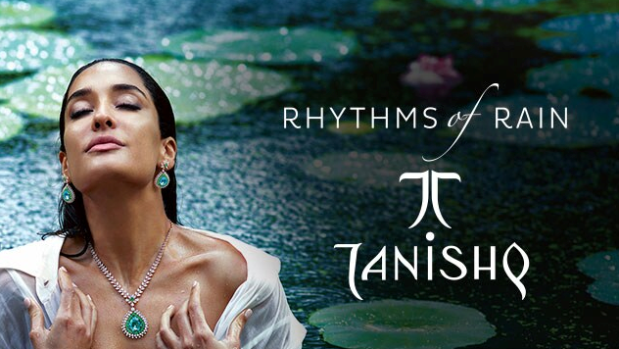

PROJECT: TANIISHQ

**-ROHIT GADEKAR | EDUREKA INTERN**

OVERVIEW:

Tanishq, the first jewellery retail brand in India, is from Titan Company Ltd (Tata Group). Headquartered in Bengaluru, it is one of the largest and most successful brands in the Indian jewellery market today.

GOALS:

1. Home Page
2. Poduct Page
3. Detailed Page

PAGE STRUCTURE:

Home Page:

* + Header
    - Store Locator
    - Account login
    - Wishlist
    - Cart
    - Jewellry Type
  + Shop by category
    - Ring
    - Coins
    - Bracelets
  + Shop by gender
    - Women
    - Men
    - Kids
  + Connect with us
    - Connect On WhatsApp
    - Book an Appointment
    - Schedule a Video Call
  + Footer
    - Useful links
    - Information
    - Contact Us
    - Social Media

Product Page:

* + Sort By
    - Best Sellers
    - New Arrivals
    - Popularity
    - Price
  + Products
    - Explore Now

Detailed Page:

* + Product Details
    - Specification
    - Review Product
  + Add to Cart
    - Contact details
    - Delivery details
    - Payment
  + Talk to an Expert
    - Form Pop up- Contact details